**Solute Transport in Groundwater**

**Importance of Solute Transport in Groundwater**

• Geologic questions: ion migration, ore deposition.

• Environmental problems: contamination of drinking water by organic

compounds and metals, radioactive waste disposal, saltwater intrusion.

Drinking water standards

• **Dissolved compounds** can be toxic and carcinogenic.

• Safe Drinking Water Act directed EPA to establish MCLs (maximum

contaminant levels)

Typical values:

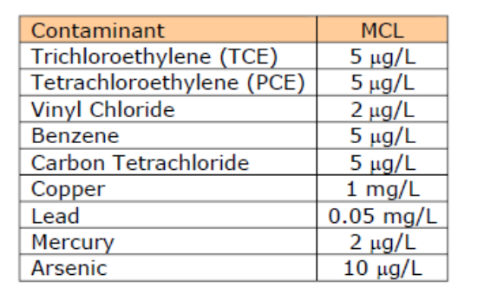

• **Immiscible compounds** serve as a source of dissolved groundwater contamination.

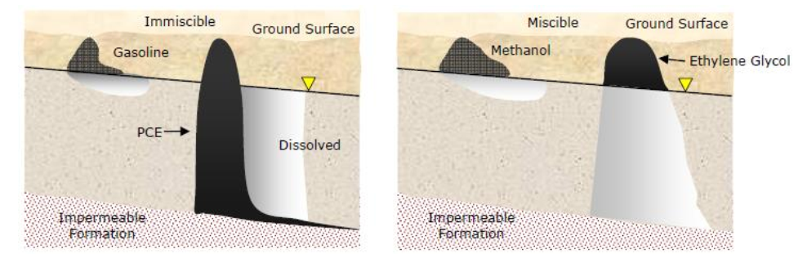

**NAPLs – non-aqueous phase liquids:**

1) LNAPL – lighter-than-water NAPL (floaters)

• For example, fuels: gasoline, diesel fuel

• Plume forms on surface of water table

• Migrates in direction of water table

• Must be skimmed.

2) DNAPL – denser-than-water NAPL (sinkers).

• For example: chlorinated hydrocarbons–TCE (1.46 sg),TCA(1.34),carbon tet

(1.59)

• Can sink to bottom of aquifer to form pool.

• Can migrate down dip on aquifer bottom.

|  |  |
| --- | --- |
| • | Recovery difficult to impossible. *The problem:* |

• Easy to contaminate.

• Low concentrations are bad.

• Substances can migrate with flowing groundwater.

• Hard to remove.

**Dissolved Substances**

A **solute** is a substance dissolved in a liquid

• Example: Chloride is a **solute** and water is the **solvent**

• Concentrations measure in [Mass/Length] (mg/L)

Representing data involving dissolved substances, C(x,y,z,t)

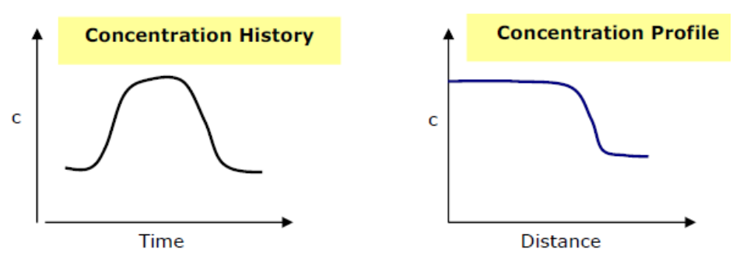

**Processes of Solute Migration**

1) **Advection** – movement of the solute with the bulk fluid where it moves with the average velocity of the water.

• Recall from Darcy’s law we have linear average velocity:

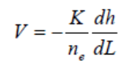

• Advective flux is simply velocity of water times the solute concentration Fadvec = VC

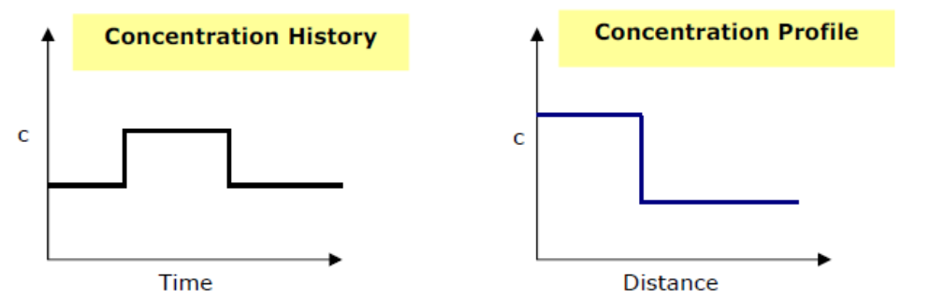

2) **Hydrodynamic dispersion** – spread of a solute plume involving the mixing of solute with native groundwater

• ***Molecular diffusion*** – spread of solute molecules due to thermal motion (function of temperature)

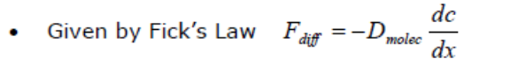

where:

*Dmolec*=the diffusion coefficient in porous media (value less than that in water);[L 2 /T]

*dc/dx* = the concentration gradient.

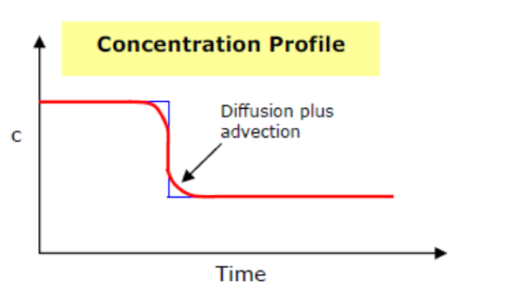

Get a narrow mixing zone where concentrations are smeared out.

**Important Observation** – mixing zone seen in lab or field is much bigger than can be explained by diffusion alone.

Lab experiments show:

• Spreading exists.

• Spreading is more intense than due to diffusion.

• Spreading depends on groundwater velocity.

• Fick’s law applies, but the “D” is much bigger.

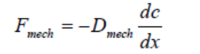

This is due to ***Mechanical Dispersion*** – the mixing that occurs because the porous media forces some solute molecules to move faster than others while following a tortuous path through pores of different sizes

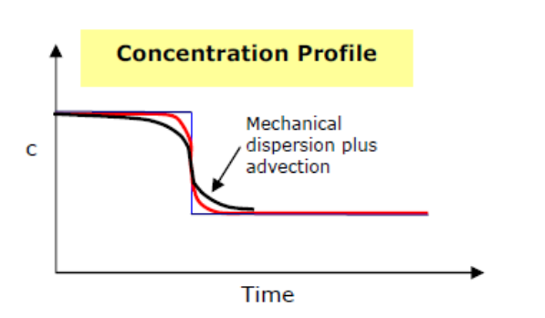

Velocity variations due to: for example –

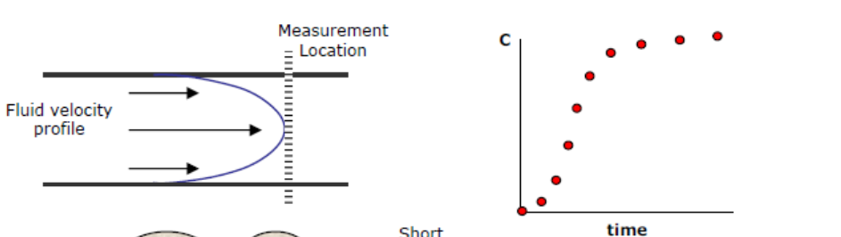

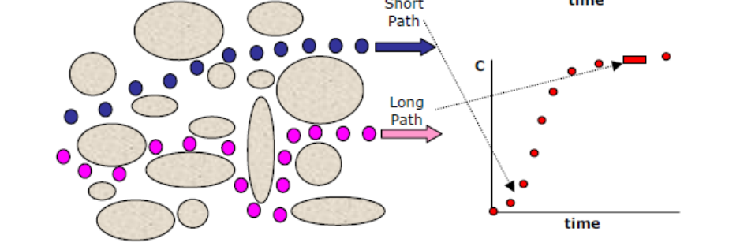

Mechanical dispersion from lab fits:

D*mech*= α|V|

where α is the **dispersivity** with units of length [L]

The **Hydrodynamic Dispersion Coefficient** consists of

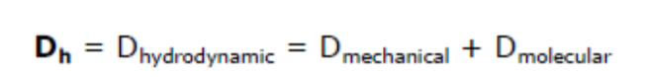

NOT to be confused are:

**Dispersion** – the spreading or mixing process.

**Dispersion Coefficient** – the D with units of [L2/T]

**Dispersivity**– spreading or mixing parameter, a length, [L]

The flux of solute is due to:

• Advection (the main process)

• Dispersion (hydrodynamic dispersion)

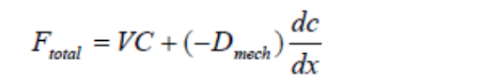

**Solute Transport Equation**

Recall development of flow equation: Conservation of mass + some empirical law. For transport of a nonreactive solute we use the above definition for flux as the empirical law giving in 1D:

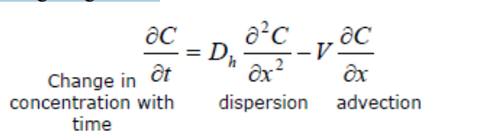

in uniform steady flow (one direction) the 2D transport equation is:

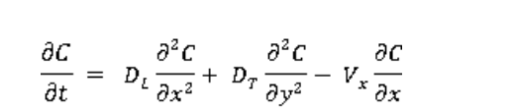

Where the longitudinal hydrodynamic dispersion coefficient (DL) is:

DL = αL|V|

αL is the longitudinal dispersivity.

The transverse hydrodynamic dispersion coefficient (DT) is:

DT = αT|V|

αT is the transverse dispersivity (much smaller than αL).

Note: In 2D if flow is in two directions then you get 4 dispersion terms and two advective terms and the form of the “D”s is more complex).

From a pulse injection you get a plume (a cloud) of solute that migrates via advection and spreads longitudinally (mostly) and transversely (a bit) – Mass is conserved.

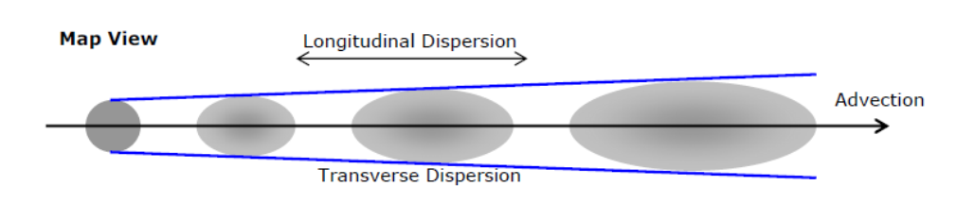

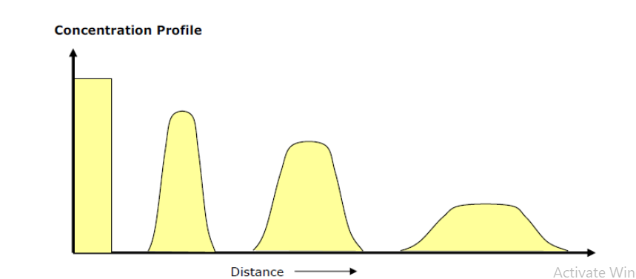

**GROUNDWATER FLOW TO PUMPING WELLS**

Water may have to be extracted from formations ranging from sand, silt, clay, fractured rocks of different compositions etc., A well may be dug to extract water from a confined or an unconfined aquifer. Digging of more than one well in close vicinity affects each other’s yield as the drawdown of one influences the other. This may be quantitatively estimated by theories of ground water flow applied to the radial flow of water to each well. In this lesson, these theories are discussed, which would be helpful in designing such wells.

**STEADY STATE GROUNDWATER FLOW TO PUMPING WELLS**

When wells have been pumping for an appreciable time steady state conditions may prevail. It is only under state conditions that continued abstraction of ground water is feasible. If not, groundwater levels will continue to decline, which finally will results in the well falling dry or in a complete exhaustion of the groundwater reservoir. Hence, it is important to understand the relationships under which steady state groundwater flow to pumping wells can occur.

**Pumping in a confined or semi-confined aquifer**

Consider a well that is pumping continuously with a constant rate Q in a confined or semi-confined aquifer with constant thickness b and homogeneous hydraulic conductivity K. The situation is depicted in Fig. 1.

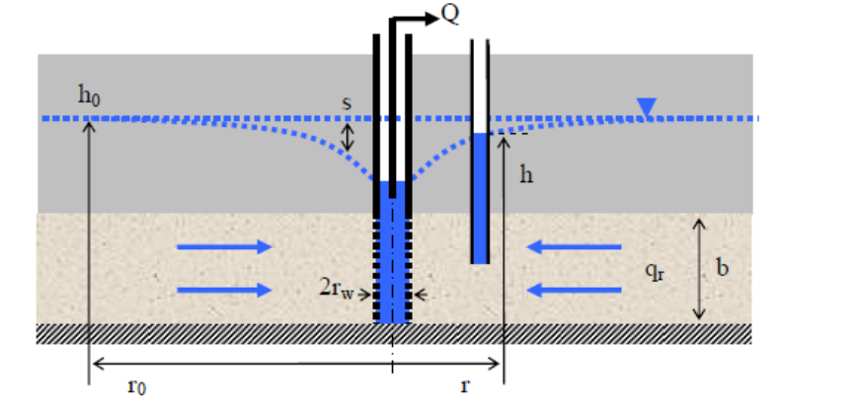

Fig. 1 Steady state groundwater flow towards a pumping well in a confined or semi-confined aquifer.

Originally, when the well was not pumping the groundwater head was at a level h0, which can be assumed more or less constant in the vicinity of the well. When the well is pumping a cone of depression is formed that enables groundwater flow towards the well. The flow can be considered completely radial towards the well if the well is screened throughout the entire thickness of the aquifer. If qr is the radial groundwater flux at a distance *r* from the well, it follows from the mass balance equation that the total radial flow towards the well should be equal to the pumping rate

Q = -2πrbqr (1)

where the minus sign expresses the fact that qr is negative as it is directed against the positive sense of the radial axis r.

Using Darcy’s law to express the groundwater flux this becomes

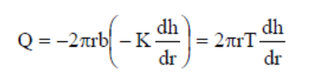

where T is the transmissivity of the aquifer. From this equation it follows

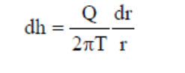

This equation can be integrated to obtain an expression for the groundwater head h

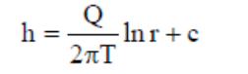

where c is an integration constant, whose value can be obtained by stating that at a distance r0 from the well the groundwater head is equal to its original natural level h0

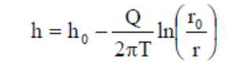

This radius r0 is called the radius of influence; it determines the zone in which the pumping well creates a cone of depression and influences the groundwater flow and head. Outside this zone for r > r0 there is no influence and h equals h0.

The drawdown s is defined as the difference in groundwater head due to the pumping well



This equation states that the drawdown is proportional to the pumping rate Q and inversely proportional to the transmissivity of the aquifer. Hence, large drawdown will occur in aquifers with a low transmissivity and for wells with a high pumping rate. This equation also states that the drawdown increases towards the well according to the logarithm of the distance. The maximum drawdown occurs at the well screen and is given by

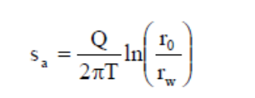

Where sa is the drawdown in the aquifer at the well screen and rw is the outer radius of the well screen (including a filter pack if present). The relationship between drawdown and the logarithm of the distance is shown in Fig. 2

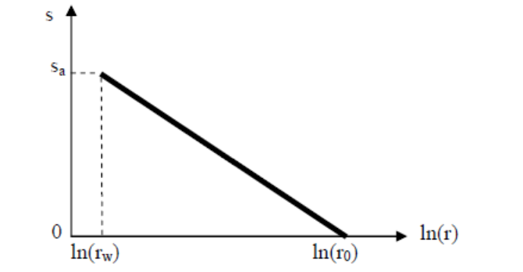

Fig. 2 Drawdown versus logarithm of the distance in case of a confined or semi confined aquifer.

**Pumping in an unconfined aquifer**

Consider now a well that is pumping continuously with a constant rate Q in an unconfined aquifer with homogeneous hydraulic conductivity K. The situation is depicted in Fig. 3.

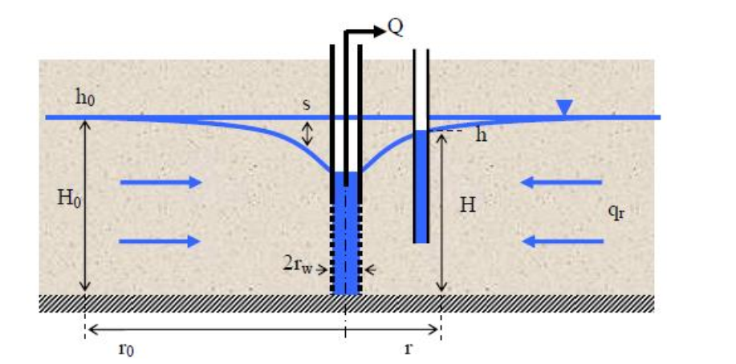

Fig.3

Originally when the well was not pumping the groundwater table was at a level h0, or H0 above the base of the aquifer, which can be assumed more or less horizontal in the vicinity of the well. When the well is pumping a cone of depression is formed that enables groundwater flow towards the well. This also causes a decrease of the water table such that the position H of the water table measured from the base of the aquifer becomes variable. The mass balance equation now becomes



Using Darcy’s law to express the groundwater flux this becomes

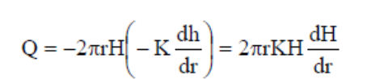

From this equation it follows

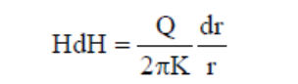

This equation can be integrated to obtain an expression for the water table position H

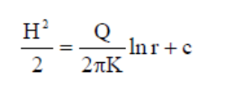

where c is an integration constant, whose value can be obtained by stating that at a distance r0 from the well the groundwater table is equal to its original natural position H0

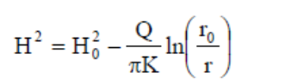

The drawdown s is the difference in water table position due to the pumping well

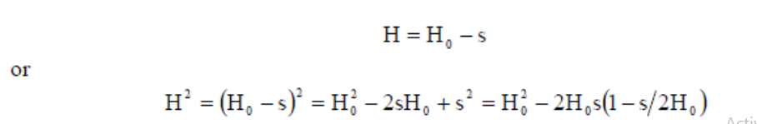

When this result is substituted in equation 12 it follows

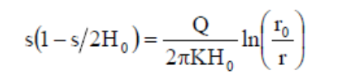

This shows that the relationship between drawdown and logarithm of the distance is slightly non-linear; this results from the fact that the drawdown also reduces the transmissivity of the aquifer. Usually there are two ways to deal with this. The first way is an approximation: if the drawdown is small with respect to the original thickness of the aquifer s/2H0 can be neglected compared to 1, hence

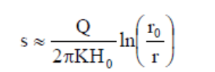

In this case the result becomes identical as for a confined aquifer, given by equation.The second approach is to define a pseudo drawdown s’ given by

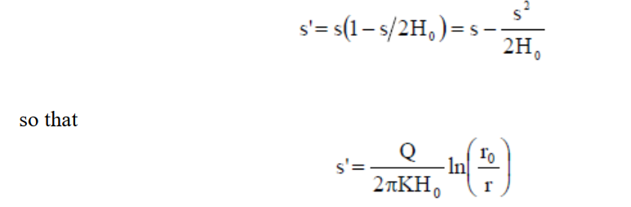

which is also similar to equation 7. The relationship between the pseudo drawdown, the drawdown, and the logarithm of the distance is shown in Fig. 4.

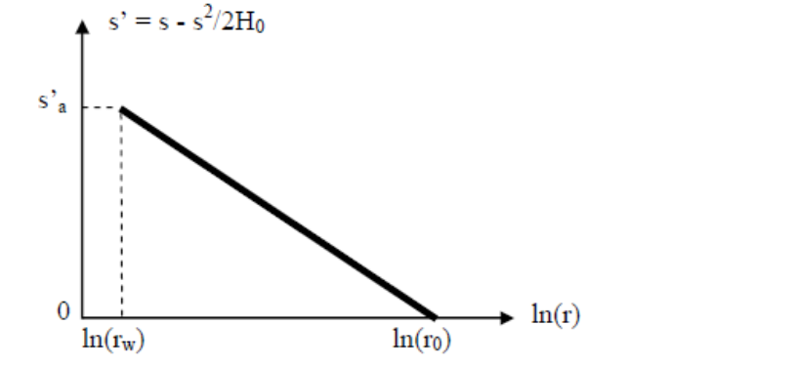

Fig. 4 Drawdown versus logarithm of the distance for an unconfined aquifer.